Deep perineal pouch and urogenital diaphragm

Deep perineal pouch

Location
It is an interfascial space across the pubic arch & above the perineal membrane.
It is closed on all sides.
Contributes to the formation of pelvic floor.

Boundaries of deep perineal pouch
Above: superior fascia of urogenital diaphragm.
Below:perineal membrane.
In front: transverse perineal ligament.
Behind: fusion of upper & lower boundaries.
On each side: ischiopubic rami.
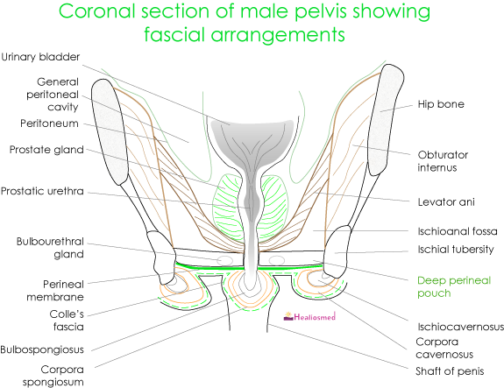

Contents – muscles
- Sphincter urethrae
- Deep transverse perenei
- Compressor urethrae(F)
- Sphincter urethrovaginalis(F) (muscular branches of perineal nerve)

Contents – vessels
Internal pudendal artery passes on each side along pubic arch & divides into 3 terminal branches.
- Deep artery of penis/clitoris.
- Dorsal artery of penis/clitoris.
- Artery to the bulb of penis/vestibule.

Contents – nerves
- Dorsal nerve of penis / clitoris.
- Muscular branches from perineal nerve.

Other contents
Membranous urethra
Vagina (F)
Bulbourethral glands (M)
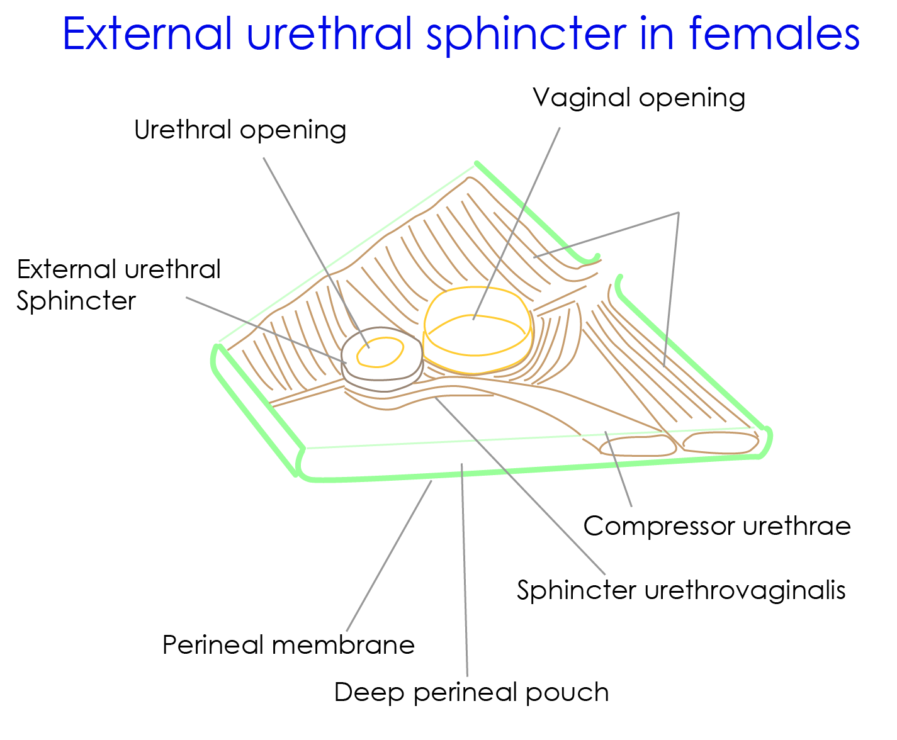

Urogenital diaphragm
It is a Musculo-fascial partition across the pubic arch separating the pelvic cavity from the anterior part of the pelvic outlet.
Consists of 2 muscles:
- Sphincter urethrae &
- Deep transverse perinei
Both the muscles are supplied by muscular branches of perineal nerve.
2 fasciae
Superior fascia
Inferior fascia/ perineal membrane.
Urogenital diaphragmIt is pierced by
Urethra.
Vagina (F)

Urogenital diaphragm – relations

Superiorly:
- Anterior fibres of both levator ani muscles.
- Anterior recess of ischorectal fossa.
- apex of prostate (M).
- Neck of bladder(F).

Inferiorly:
- Contents of superficial perineal pouch.

Anteriorly:
- Transverse perineal ligament.

Posteriorly:
- Ischiorectal fossa.

Actions of urogenital diaphragm
- It supports the prostate & bladder.
- It constricts the vagina (F).
- It fixes the perineal body.
- Sphincter urethrae muscle exerts voluntary control of micturition & expels the last drops of urine after bladder stops contracting.
